John Michael Go
Career Entry Level Java Programming
Date: Jan. 22, 2013

DAY 8

Program Name: Array5

Objective: Program that averages the values of an array.

Algorithm:

- Program averages the values of an array.

Flowchart:

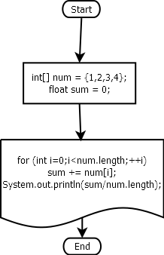

Pseudocode:

public class Array5 {

public static void main(String[] args) {

int[] num = {1,2,3,4};
float sum = 0;
for (int i=0;i<num.length;++i)
sum += num[i];
System.out.println(sum/num.length);

}

}

Screenshots:

